4.1 SDP Plan Introduction

This Software Development Plan provides the information regarding the schedule/plan for the development of Keyboard Warrior, which provides an application to help users improve their typing skills in the form of a video game.

4.1.1 Project Deliverables

* Project Proposal Document
  + Document containing a description of the project and the justification for its creation
* Software Requirements Specification
  + Document specifying what exactly is being built for the project
* Software Development Plan Document
  + Document describing the process that will be used during the projects period of development
* Written Status Reports
  + Biweekly reports on the projects development, specifying tasks currently being worked on, future tasks, and current troubles

4.2 Project Resources

* Sebastian Cruz
  + Responsible for all planning and development

4.2.1 Hardware Resources

* Windows laptop

4.2.2 Software Resources

* Unity game engine software

4.3 Project Organization

The project is divided into 2 major functions: typing and combat

The typing functionality is responsible for allowing the user to type words generated from a json file and receive feedback on their accuracy and speed of typing. The development plan will begin with setting up player typing and the generation of random words from a list, checking correctness of user input, calculation of WPM, chances of generating words from more difficult lists.

Combat functionality is responsible for using the typing functionality to apply damage to either the player or the enemy. It is also responsible for creating an attack pattern for the enemy that the player must react to by switching between attacking and defending. The development plan will begin with setting up player stance changes, player and enemy object creation, damage applied from correct typing, enemy attacks, dodge notifications.

4.4 Project Schedule

The following section provides scheduled information for Keyboard Warrior.

4.4.1 GANTT Chart

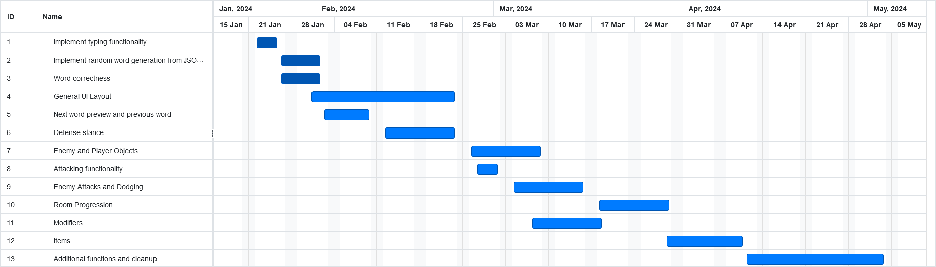

4.4.2 Task / Resource Table

* Because this is an individual project, all tasks will be completed by Sebastian Cruz
* Because the project is developed solely through Unity, all tasks will require Unity game engine software and a device with Windows